The (unintended) effects of the GDPR on program evaluation: Field Evidence from an Energy Saving Program

Martin Kesternich, Michael K. Price

Version: January 27, 2023
Abstract:
While the General Data Protection Regulation (GDPR) clearly affects both business and administrative processes where personal data is collected, less attention has been paid so far on its potential impact on science-based policy evaluation. We study the role of selection issues that may emerge from systematic differences between subjects that opt into an evaluation study and those who remain outside because they have neglected processing their personal data. We shed light on the presence and impact of this potential threat to scalability by reporting field evidence from a household energy saving program which was launched during the implementation phase of the GDPR. We show that the likelihood of signing the data sharing consent for personal electricity consumption profiles is correlated with certain sociodemographic characteristics. At the same time, these variables do have a significant impact on our major outcome variable, i.e. electricity consumption. Consequently, the relatively higher share of households with lower electricity consumption profiles in the study sample might have an impact on the causal analysis of the program, probably resulting in a conservative estimate of the true average treatment effect.

JEL: C93, D12, D18, L94, Q41

Acknowledgement: This work has been funded by the H2020 Framework Programme of the European Union (Project No. 649733) We thank all collaborating partners within the EU project for their tireless efforts.

Correspondence:
Martin Kesternich: ZEW – Leibniz Centre for European Economic Research and University of Kassel, martin.kesternich@zew.de

Michael K. Price: University of Alabama, Australian National University (ANU), Leibniz Institute for Economic Research (RWI), mkprice2@cba.ua.edu

Introduction
Given the advances in information technology, consumer data becomes increasingly precise and insightful. Therefore, their value has constantly risen over the past years. At the same time, these advances may lead to a threat of privacy concerns and reduce the amount of control over personal data. In the worst case, it even opens up the possibility of a range of negative consequences as a result of access and misuse of personal data. As a consequence, regulating entities have started to enact privacy regulation which empower consumers to have more control over data which they generate. As an important example for such a regulation, the European Union (EU) in 2016 has adopted the General Data Protection Regulation (GDPR) (EU 2016/679) which aims at harmonizing the protection of fundamental rights and freedom of natural persons in respect of processing activities and at ensuring the free flow of personal data between EU member states (Number 3). While the GDPR clearly affects both business and administrative processes where personal data is collected (see e.g. Zhuo et al. 2021), less attention has been paid so far on the impact of the GDPR for scientific research and, in particular, to its potentially unintended consequences for causal analysis. In terms of policy evaluation, two potential threats of selection which reduce the external validity of evaluation studies appear to be relevant.
The first channel through which selection might occurred refers to the ambiguity on how firms or individuals interpret the GDPR and, accordingly, how personal data is processed. Recent survey evidence from more than 500 German firms shows that 78% of all firms perceive legal uncertainty as the major challenge for implementing the GDPR requirements in practice. (Dehmel and Rohleder 2022). 93% of all firms which had reported new, innovative projects within the last twelve months state that at least one project had failed due to the insecurity in dealing with the specifications of the GDPR .
In line with these insights, a survey conducted among 600 German firms in the ICT sector reveals that only 19.5% of them think that the GDPR has led to more legal certainty. This skeptical assessment towards the legal certainty spans from ICT hardware (20.1%) and ICT service providers (28.9%) to media service providers (19.6%) to knowledge-intensive service providers (16.7%). It also holds for small firms (5-19 employees) (16.7%), mid-size firms (20-99 employees) (26.9%) and large firms (> 100 employees) (33.4%). This is not only a relatively small share but most notably has further decreased (by 11 percentage points) compared to a previous survey wave conducted among these firms in 2017 just before the GDPR entered into force (ZEW Business Survey in the Information Economy 2020).
The second channel, which is at the core of this paper, refers to selection issues that potentially emerge from differences in observable characteristics between subjects who opt into an evaluation study and those who remain outside because they neglect processing their personal data. Empirical evidence for this threat of selection is difficult to obtain because usually evaluation studies do not contain information on those who had refused to share their data. In a short online survey on personal attitudes towards the GDPR regulation that we conducted among about 500 participants in the Rhine-Neckar-Region in December 2020, 46.1% of all participants fully agree with the statement that the government should issue stricter rules for data protection and 54.5% consider the GDPR only as a partly effective instrument. As a consequence, there is a certain degree of reluctance to provide personal data even for scientific research across various domains. 28.1% of all survey participants would provide their data only in exceptional cases for research projects that deal with individual financial data, 20.5% would not be willing to share this data at all. For the case of household energy data, 21.5% would share their data only in exceptional cases and 11.2% neglects to share personal data on household energy consumption via e.g. energy bills.
Our paper sheds light on the presence and the impact of these potential selection issues by reporting insights from an experimental intervention within an energy saving campaign which was conducted just during the implementation phase of the GDPR. We have collected both pre-intervention survey data from households who later on signed the consent to share further personal information on our major outcome variable of interest, i.e. the daily household electricity consumption provided by the local energy supplier and those who refused to do so. We find that the likelihood of signing the consent for sharing electricity data is correlated with some demographic characteristics such as age and homeownership. At the same time, we find that these variables are correlated with our major outcome variable: Both age (-9.4% to 9.7%) and homeownership (about -10.9%) affect the pre-intervention electricity use. Consequently, the relatively higher share of households with lower electricity consumption profiles in our study same might have an impact on the causal analysis of the program, probably resulting in a conservative estimate of the true average treatment effect.

Basic elements and implementation of the General Data Protection Regulation (EU) 2016/679
The General Data Protection Regulation (EU) 2016/679 (GDPR) is a regulation on data protection and privacy in the European Union (EU) and the European Economic Area (EEA). It was adopted on April 14, 2016 and entered into force on May 25, 2018. The GDPR is a regulation, and not a directive, meaning that it became directly binding and applicable. It does however provide some flexibility with respect to certain aspects which can be adjusted by the individual member states.
The GDPR aims at protecting natural persons with regard to the processing of personal data and on the free movement of such data, thereby addressing the everybody’s fundamental right to the protection of personal data concerning him or her (GDPR, Number 1). In particular, Article 5(1a) states that personal data shall be processed lawfully, fairly and in a transparent manner in relation to the data subject. Data shall be collected for specified, explicit and legitimate purposes (Article 5(1b)). It also highlights the principle of data minimization, claiming that personal data shall be adequate, relevant and limited to what is necessary in relation to the purpose for which they are processed (Article 5(1c)).
At the same time, GDPR states that the right to the protection of personal data is not an absolute right as it must be considered in relation to its function in society and be balanced against other fundamental rights, in accordance with the principle of proportionality (Number 4). For scientific research, it is often not possible to identify the purpose of personal data processing at the time of data collection. (Number 33). This is why data subjects should be allowed to give their consent to certain areas of scientific research when in keeping with recognized ethical standards for scientific research. In particular, data subjects should have the opportunity to give their consent only to certain areas of research or parts of research projects to the extent allowed by the intended purpose (Number 33).
Article 6 highlights the lawfulness of processing. Processing is lawful if the data subject has given consent to the processing of his or her personal data for one or more specific purposes (Article 6(1a). It is however also lawful if processing is necessary for the performance of a task carried out in the public interest (Article 6(1f)).

The Energy Saving Program
We study the effects of the GDPR regulation on the evaluation of a household energy saving campaign which was launched in the City of Warsaw in Poland and started in March 2016. The program was developed and initiated by an SME specialized in environmental engineering, change management and software development. At the heart of the program, the program designers developed a web-based platform which promotes energy savings and pro-environmental behavior among households, thereby building up on different communication strategies including energy saving tips, reminders, feedback and sharing customers’ experiences. The program has been rolled out in different European cities and communities. In our case study, we take the City of Warsaw as our reference case where GD6D was implemented in 2016.
To start the recruitment of households, trained local advisors organized door-to-door visits in a pre-selected area of the City of Warsaw which is called Gocław (see Figure 1) a part of the disctrict Praga-Południe. Gocław mainly consists of building blocks that have been constructed during communist time. Praga-Południe has about 180,000 inhabitants in total (City of Warsaw: 1,8 Mio, see Table 1, right panel). Since apartments in that time have been assigned to a mixed population and are mainly still owned by the descendants of these first owners, the inhabitants of Gocław vary largely in their sociodemographic characteristics. Average housing prices are about 9% lower (8,733 PLN (~ 2,240 USD) per m² for a flat, 3rd quarter of 2018) compared to the average value for the City of Warsaw (9,609 PLN (~2,465 USD)).
Figure 1: Map of the City of Warsaw (left) and Gocław (right)
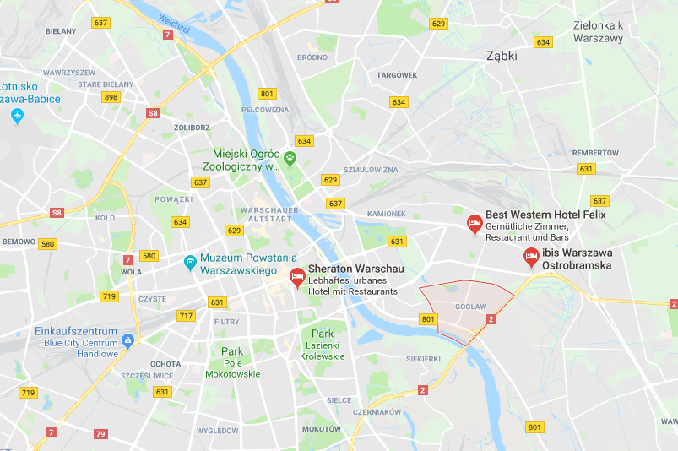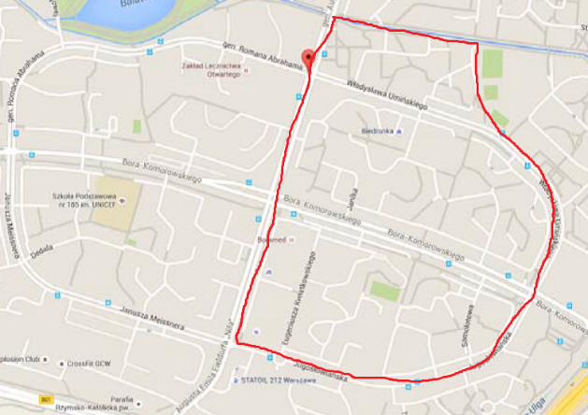
Table 1: Summary statistics of experimental and administrative data
 | Experimental data |  |  | Administrative data
 | Sign-up + consent | Sign-up only |  | Praga-Południe | City of Warsaw
Inhabitants  (June 30, 2018)  Registered  Total |  |  |  | 167.904  179.015 | 1.631.751  1.769.529
 | in shares | in shares | Chi²- test on differences in proportions
Age  less than 25  between 25 and 35  between 35 and 45  between 45 and 55  between 55 and 65  More than 65  No information | 0.04  0.17  0.16  0.11  0.28  0.24  0.01 | 0.10  0.21  0.19  0.10  0.21  0.16  0.04 | p=0.000  p=0.002  p=0.006  p=0.236  p=0.000  p=0.000  p=0.000 | N/A | June 30, 2018  0.23 (402,505)  0.15 (264,093)  0.18 (326,127)  0.11 (196,141)  0.13 (225,031)  0.20 (355,632)
Sex  Female  Male  No information | 0.47  0.51  0.02 | 0.43  0.52  0.05 | p=0.008  p=0.485  p=0.000 | N/A | 0.55 (892,276 )  0.45 (739,475 )  (registered)
Home ownership  Tenant  Owner  No information | 0.06  0.92  0.02 | 0.21  0.74  0.05 | p=0.000  p=0.000  p=0.000 | N/A | N/A
Home size (in m²)  less than 40m²  betw 40 and 60m²  betw 60 and 100m²  betw 100 and 200  more than 200m²  No information | 0.04  0.50  0.43  0.01  0.00  0.02 | 0.07  0.50  0.35  0.03  0.00  0.05 | p=0.003  p=0.752  p=0.000  p=0.007  p=0.954  p=0.000 | N/A | National census 2011:  0.27 (198,520)  0.41 (302,897)  0.24 (176,241)  0.02 (17,835) :100-120 m²  0.05 (36,279): > 120 m²
Household members  1  2  3  4  5  6  No information | 0.17  0.39  0.23  0.14  0.03  0.02  0.02 | 0.13  0.37  0.23  0.16  0.04  0.02  0.05 | p=0.000  p=0.190  p=0.607  p=0.225  p=0.450  p=0.799  p=0.000 | N/A | National census 2011:  0.17 (287,219)  0.27 (228,974)  0.25 (141,314)  0.2 (84,919)  0.1 (32,186) 5 and more
Average price per m2 of a flat  2nd quarter 2018  3rd quarter 2018 |  |  |  | 8434 PLN  8733 PLN | 9433 PLN  9609 PLN
TOTAL | 1,497 | 2,716

Treatment group
Local advisors conducted the “cold visit” Door-to-Door (Dtd) interviews following an App-based fixed protocol. After some initial background information about the program which also included a welcome letter being signed by the mayor of the City of Warsaw a short questionnaire with clustering questions was filled by the advisors. Participants were then invited to select up to three relatively simple actions to engage in pro-environmental behavior. These actions included some simple energy saving tips, targeting both the adoption of small-scaled technological solutions (e.g. installation of an eco-performance faucet aerator to reduce (hot) water consumption, installation of an energy-saving LED light bulb) and behavioral adjustments (e.g. switching off the mobile phone at night, defrosting the freezer every three month). In addition, households received a small gift (“energy saving kit”) which contained some small appliances (a LED bulb, a draught excluder strip and a faucet aerator) to stimulate participation in the program and partly to facilitate following the energy saving tips being chosen.
In order to fulfil the obligations from the GDPR regulation, at the end of the interview participants were asked to sign a written consent which allowed the research team to link the electricity consumption data (based on daily smart meter readings) with the data from the web-based platform. For those, who signed the consent, the electricity data was then provided by the local energy provider.
The DtD interviews were conducted between April and September 2016 with a peak in August 2016 where almost 30% of total participants registered in the platform (see Figure 2). In total, 14,951 households were approached (i.e. an advisor knocked on the door in several attempts). Out of these, 3,113 households (20.8%) finally registered for participation at the GD6D platform. During the start of the DtD campaign, local advisors phased several challenges. In these times, Polish households had become rather skeptical towards “cold visits” because of trick campaigns (also related to energy saving campaigns). Therefore, local advisors started to engage more in community events in Gocław (e.g. within schools) and in open-street interviews to increase trust and to arrange a fixed appointment for a DtD visit. Given all these drawbacks during the rollout of the program, the overall participation rate in the “cold visit” approach does not seem to fall below related programs. Fowlie et al. (2015) report insights from the Federal Weatherization Assistance program in the US. This program offers free energy improvements to low-income households. Even after extensive efforts to encourage program participation, e.g. by in-person house visits, door hangers, mailed post cards and phone calls only 15% of all households in the treatment group finally submitted an application to the program and fewer than 6% of all targeted households in the end successfully enrolled in the program. Similarly, reporting field experimental evidence on the impact of high-frequency information (via in-home displays) about residential electricity usage suggests that take-up rates are rather modest (Jessoe and Rapson 2014). Out of 60,000 customers of a regulated electricity utility, who received an e-mail invitation including monetary incentive for participation, approximately only 7,000 customers opened the e-mail and only 1,152 households (about 16.5% of all who opened the email or 1.9% of all who receiced the e-mail) were finally recruited to participate in the program.
After the DtD visit, households were re-contacted up to every 4-5 weeks until November 2017 by email or phone calls by the local advisors in collaboration with a call center. Households were asked to share their experiences with the actions to promote pro-environmental behavior during the DtD campaign and were encouraged to commit to further saving tips. The coaching was managed by a web-based system which suits the suggested actions during the coaching phase individually to the profile and the past experiences of a respective household. That is, during the coaching phase and unlike during the DtD visit, households do not receive the same commitment advices but follow an individual path.

Control group
Control group households were also recruited in Gocław but in another part. Due to the GDPR regulation, control group households were also personally approached during a short visit in order to obtain their written consent for sharing their electricity data. These households were briefly informed about the major goals of the program supported by the City of Warsaw and encouraged to take part in a small questionnaire similar to that in the treatment group. In contrast to the treatment group, control group households did not commit to any actions related to pro-environmental behavior, they did not receive the energy-saving kit and were not re-contacted in the subsequent coaching period. In total, 1,100 households have been recruited to serve as a control group in the program
As depicted in Figure 2, household visits in the control group started slightly later (September – December 2016) than in the treatment group (April – September 2016). As described in the next section, electricity consumption data for households in both groups are available on a daily basis from January 2015 until November 2017, therefore covering both pre-intervention periods for both groups.
Figure 2: Recruitment of treatment and control group households
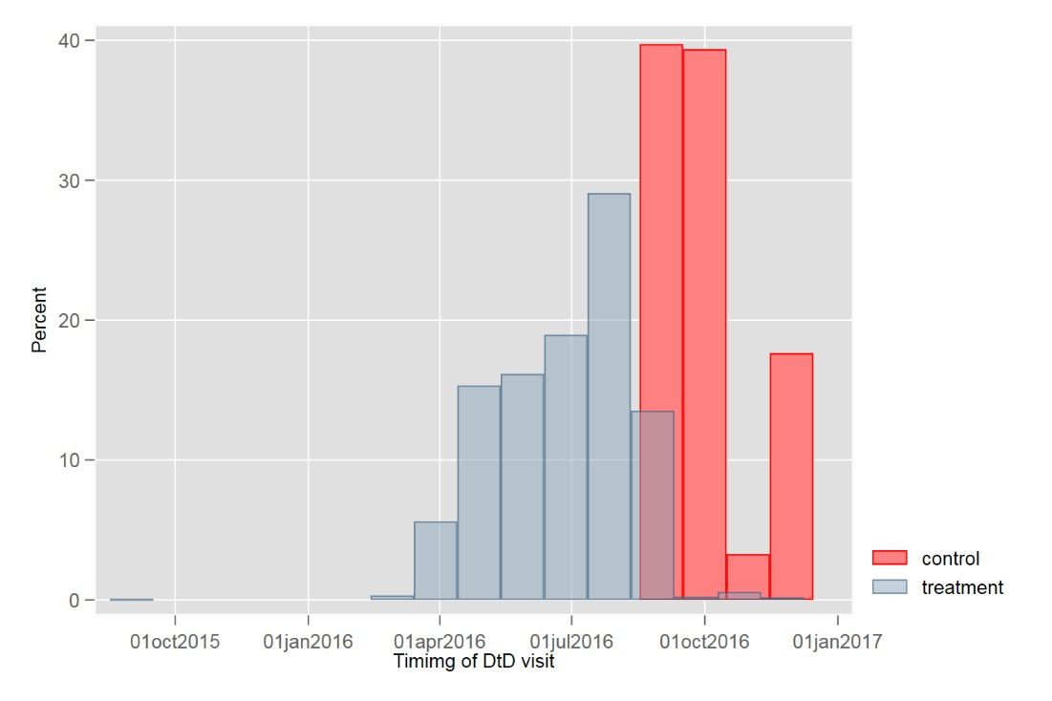

Data collection
We collect household data in different waves and combine different sources of data. The first wave of data (“pre-survey”) was collected during the DtD visit both in the treatment and in the control group as described above. This survey collects basic information on demographic and housing unit characteristics. The second wave of data was extracted from the web-platform in January 2018 and comprises the status of actions to promote pro-environmental behavior that have been proposed to the respective household during the DtD visit and the corresponding coaching phase. In addition, we conducted a small follow-up survey (“post-survey”) to obtain additional insights from the participating households addressing their experiences with the program.
We use daily smart meter readings on households’ electricity consumption from January 2015 until November 2017. Due to the lack of consent and other administrative issues, it should be noted that electricity data was not available for the full set of all 4,213 households. In total, we were able to link electricity data to 1,278 households of the treatment group (41.1%) and 219 households of the control group (19.9%). The number of households for which full electricity data was available varied between month, both within the treatment and the control group. To make maximum use the variation of the data, we follow the approach suggested e.g. by Jessoe and Rapson (2014) and use the unbalanced sample.

Randomization
As already indicated, the randomization did not take place at a household level. One reason for this was to facilitate the pre-announcement of the program via flyers and posters prior to and after the DtD visits in the treatment area and therefore to avoid spillover effects between the treatment and the control group. A potential caveat of this procedure is, even though the selection the areas was carefully prepared e.g. through pre-treatment assessment of sociodemographic statistics (as far as available) that households in the different groups differ with respect to their sociodemographic characteristics. We present the results of a non-parametric (Chi²) test to investigate differences in observables between the treatment and the control group in Table 2. We find that participants in the control group are significantly younger compared to those in the treatment group. The share of owners (85%) is significantly higher in the treatment than in the control group (69%). We do not find significant differences with respect to the gender of the interviewee, the number of household members and only slight differences with respect to the size of the apartment (in m²).
Table 2: Summary statistic of treatment and control group
 | Treatment |  | Control
 | % | N | % | N
Age  less than 25  between 25 and 35  between 35 and 45  between 45 and 55  between 55 and 65  More than 65  No information | 0.05 (0.224)  0.16 (0.367)  0.18 (0.384)  0.09 (0.293)  0.26 (0.438)  0.22 (0.413)  0.04 (0.184) | 166  499  560  295  804  680  109 | 0.14 (0.352) ***  0.28 (0.450) ***  0.18 (0.381)  0.12 (0.320) **  0.16 (0.363) ***  0.10 (0.303) ***  0.02 (0.152) * | 159  310  194  127  172  112  26
Sex  Female  Male  No information | 0.44 (0.497)  0.51 (0.500)  0.05 (0.210) | 1366  1603  144 | 0.45 (0.498)  0.52 (0.500)  0.03 (0.166) ** | 499  570  31
Home ownership  Tenant  Owner  No information | 0.11 (0.317)  0.85 (0.360)  0.04 (0.197) | 351  2636  126 | 0.28 (0.448)***  0.69 (0.463)***  0.04 (0.185) | 304  757  39
Home size (in m²)  less than 40m²  between 40 and 60m²  between 60 and 100m²  between 100 and 200m²  more than 200m²  No information | 0.05 (0.218)  0.50 (0.500)  0.38 (0.486)  0.02 (0.150)  0.00 (0.05)  0.04 (0.199) | 156  1559  1189  72  8  129 | 0.08 (0.270)***  0.49 (0.500)  0.36 (0.480)  0.02 (0.149)  0.00 (0.052)  0.04 (0.198) | 87  543  397  25  3  45
Household members  1  2  3  4  5  6  No information | 0.15 (0.357)  0.38 (0.485)  0.23 (0.421)  0.15 (0.357)  0.03 (0.183)  0.02 (0.135)  0.04 (0.192) | 467  1178  716  467  108  58  119 | 0.13 (0.336)  0.37 (0.484)  0.23 (0.423)  0.17 (0.372)  0.04 (0.204)  0.02 (0.137)  0.04 (0.185) | 143  410  257  182  48  21  39
TOTAL |  | 3,113 |  | 1,100
Note: Shares are reported by treatment and control group, standard deviations in parentheses, asterisks indicate significant differences between the treatment and the control group in proportions (Chi²-test), ***p<0.01, **p<0.05, *p<0.10

Preliminary Results
In order to fulfil the obligations of the GDPR regulation, advisors asked interviewees to sign a written consent at the end of the door-to-door campaign. This consent allowed the electricity provider to share the smart meter readings of the respective households both in the treatment and the control group. While, in total 1,497 (35.5%) out of 4,213 households that registered on the web-based platform signed the form, 2,716 (64.5%) refused to do so. In a first step, we analyze whether acceptance of signing the consent varies with treatment assignment and sociodemographic characteristics of the participants.

Table 3: Effect of treatment assignment and sociodemographic characteristics on consent
 | (1) | (2) | (3) | (4) | (5)
 | Consent | Consent | Consent | Consent | Consent
Treatment | 0.227*** | 0.207*** | 0.208*** | 0.203*** | 0.176***
 | (0.017) | (0.018) | (0.018) | (0.018) | (0.018)
Age55+ |  | 0.098*** | 0.097*** | 0.097*** | 0.060***
 |  | (0.015) | (0.015) | (0.015) | (0.015)
Female |  |  | 0.027* | 0.027* | 0.024*
 |  |  | (0.015) | (0.015) | (0.015)
60m²+ |  |  |  | 0.040*** | 0.024
 |  |  |  | (0.015) | (0.015)
Owner |  |  |  |  | 0.260***
 |  |  |  |  | (0.026)
Observations | 4,213 | 4,078 | 4,078 | 4,033 | 4,011
Notes: Average marginal effects after binary logit regression, dependent variable: Consent equals to one if participant signed the written consent; independent variables: Treatment equals to one if participant had been assigned to the treatment group; Age55+ equals to one if the participant is at least 55 years old; Female equals to one if participant is a woman, 60m²+ equals to one if participants’ home size larger than 60m²; Owner equals to one if participant is the owner of his apartment; standard errors in parentheses; *** p<0.01, ** p<0.05, * p<0.1

Our regression results indicate that the likelihood of signing the consent clearly differs between the treatment and the control group in all our econometric specifications (Models 1-5, Table 3). In our richest specification (Model 5), participants in the treatment group are 17.6 percentage points more likely to sign the consent compared to those in the control group (p<0.01). Moreover, we find that older people (+ 6.0 percentage points) and home owners (+ 26 percentage points) have a higher likelihood to enroll in the program and to accept sharing their electricity data (both p<0.01). We also find some (weaker) gender effects (+ 2.4 percentage points for women, p<0.1). While these results provide first insights on determinants of selection into the program it remains unclear whether these variables interact with the major outcome variable (i.e. electricity consumption) of the program.
As post-intervention electricity data is obviously only observable for those who provided consent, we use pre-intervention electricity data to study whether the main explanatory variables for consent are also informative to explain pre-intervention electricity use.
Table 4: Determinants of mean daily pre-intervention electricity use
 | (1) | (2) | (3) | (4) | (5)
 | ln(kwh) | ln(kwh) | ln(kwh) | ln(kwh) | ln(kwh)
Treatment | -0.002 | 0.015 | 0.015 | 0.009 | 0.007
 | (0.032) | (0.032) | (0.032) | (0.031) | (0.031)
Age55+ |  | -0.095*** | -0.096*** | -0.097*** | -0.094***
 |  | (0.023) | (0.023) | (0.022) | (0.022)
Female |  |  | 0.042* | 0.026 | 0.025
 |  |  | (0.023) | (0.022) | (0.022)
60m²+ |  |  |  | 0.210*** | 0.210***
 |  |  |  | (0.022) | (0.022)
Owner |  |  |  |  | -0.109**
 |  |  |  |  | (0.046)
Constant | 1.538*** | 1.573*** | 1.554*** | 1.471*** | 1.575***
 | (0.030) | (0.031) | (0.032) | (0.032) | (0.053)
Observations | 1,485 | 1,464 | 1,464 | 1,453 | 1,448
R-squared | 0.000 | 0.012 | 0.014 | 0.072 | 0.076
Notes: OLS regression, dependent variable: ln(kwh) captures the logarithm of the mean daily pre-intervention use (e.g. before March 2016) per household; independent variables: Consent equals to one if participant signed the written consent; independent variables: Treatment equals to one if participant had been assigned to the treatment group; Age55+ equals to one of participant is at least 55 years old; Female equals to one if participant is a woman, 60m²+ equals to one if participants’ home size larger than 60m²; Owner equals to one if participant is the owner of his apartment; standard errors in parentheses; *** p<0.01, ** p<0.05, * p<0.1

We do not find evidence that mean daily pre-intervention electricity use differ significantly between treatment and control group households in our sample (Table 4, columns 1-5). There is however evidence that older people consume less electricity (about 9.4-9.7%, p<0.01, models 1-5). This is particularly of interest, since – as shown in Table 3 and discussed above – older people are more likely to engage in the program and provide a written consent. Analogously, we report home owners to consumer less electricity (about 10.9, p<0,05) but at the same time have a significantly higher likelihood to enroll in the program and accepting sharing their electricity data.

Conclusion
While there is a growing interest in the impact of data privacy regulations on business and administrative processes where personal data is collected, less attention has been paid so far on the impact on science-based policy evaluation. In this paper we study the role of selection issues that may emerge from systematic differences between subjects that opt into an evaluation study and those who remain outside because they have neglected processing their personal data. Our study benefits from an empirically favorable setting by reporting experimental evidence from a household energy saving program which coincides with the implementation of the EU General Data Protection Regulation (GDPR). While, in a first step, we have collected baseline survey data on household characteristics from all potential program participants, in a second step we have obtained personal electricity consumption profiles only for those who had signed a data sharing consent for the electricity data. This allows us to systematically evaluate potential differences between these two groups and assess the impact on the causal program evaluation. We provide evidence that the likelihood of signing the data sharing consent is correlated with certain sociodemographic characteristics. At the same time, these variables do have a significant impact on our major outcome variable of interest, i.e. electricity consumption. Consequently, the relatively higher share of households with lower electricity consumption profiles might have an impact on the causal analysis of the program, probably resulting in a conservative estimate of the true average treatment effect.

References
Dehmel S, Rohleder B (2022), Datenschutz in der deutschen Wirtschaft: DS-GVO & internationale Datentransfers.
Fowlie BM, Greenstone M, Wolfram C (2015), Are the Non-Monetary Costs of Energy Efficiency Investments Large ? Understanding Low Take-up of a Free Energy Efficiency Program †, American Economic Review: Papers and Proceedings 105, 201–204.
Jessoe K, Rapson D (2014), Knowledge is ( Less ) Power : Experimental Evidence from Residential Energy Use, The American Economic Review 104, 1417–1438.
ZEW Business Survey in the Information Economy (2020), ZEW Business Survey in the Information Economy [WWW Document]. URL https://www.zew.de/en/presse/pressearchiv/viele-unternehmen-stellen-dsgvo-schlechtes-zeugnis-aus/?cHash=4fda5fb3c5661939e5016b405c2c406d. (accessed 1.26.23).
Zhuo R, Huffaker B, Claffy K, Greenstein S (2021), The impact of the General Data Protection Regulation on internet interconnection, Telecommunications Policy 45, 102083.

Appendix 1: Written consent (translated from Polish)
Working project
07.09.2015
Declaration of consent to participate in the [name of the] project implemented by the Capital City of Warsaw
1. as the owner/tenant being a party to a contract for the supply of electricity and heat in premises no.... I agree to participate in the research project [name of the] financed from the European Union Programme Horyzont2020, the aim of which is to reduce energy consumption in the premises by changing the behaviour of the premises' users, and I agree to participate free of charge:
1.1 Providing by the [name of the electricity provider] data on electricity consumption in the premises I occupy, in the form of hourly consumption profiles and total monthly electricity consumption in the premises I occupy from 1 June 2013. until the completion of the project, [name of the research institute 1] with its registered office at [address of the research institute 1], [name of the research institute 2] with its registered office at [address of the research institute 2], [name of the SME] with its registered [address of the SME] and the European Commission and entities authorized by it.
1.2 Monitoring and analysis by the [name and address of the research institute 1], [name and address of the research institute 2], [name and address of the SME] the data on media consumption in the premises I occupy until the date of completion of the project and I am aware that the data will be presented only in an anonymous manner.
1.3 Processing by the City of Warsaw with its registered office at 3/5 Bank Square in Warsaw, [name and address of the research institute 1], [name and address of the research institute 2], [name and address of the SME] and the European Commission and entities authorized by it to process my personal data in accordance with the provisions of the Act of 29 August 1997. on the protection of personal data (uniform text: Journal of Laws of 20154 , item 2135 1182 as amended), art. 7 and art. 23 section 1, covering [name and surname, address of residence, tel, e-mail address, data on electricity consumption in the place of residence in the established time units] by means of their [recording, collecting in a traditional form and in an IT system] for the needs of the above mentioned project and only during the period of its implementation, and I acknowledge that the City of Warsaw with its seat at 3/5 Pl. Bankowy, 00-950 Warszawa, will perform the duties of the Personal Data Administrator specified in the aforementioned Act. My consent to the processing of personal data is voluntary, I have been informed about my right to access and correct my data. Providing the data is voluntary, however, without providing it, it is not possible to participate in the programme.
I have been informed about the purpose of the [name of the] project and the associated procedures.
3. I understand the purpose of the project and agree to use the services provided by the [name of the] together with all other household members.
4 I am aware that participation in the project is entirely voluntary and free of charge. I know that I may resign from participation in the study at any time by submitting a written statement to the Infrastructure Office of the City of Warsaw at 77/79 Marszałkowska Street, 00-683 Warsaw.
The statement has been prepared in two identical copies, one for the City of Warsaw (partner in the [name of the] project) and the Participant.
Participant:
Participant's residential address:
Participant's telephone number:
Participant's e-mail address:
Electricity meter number:
On the basis of Article 23(1)(a) and (b) of the Treaty on the Functioning of the European Union. 1 of the Act of 29 August 1997 on the protection of personal data (Journal of Laws of 20145, item 2135 1182 as amended), I consent to the processing of my personal data by the President of the Capital City of Warszaway for the purposes of implementing the [name of the] Project.

Warsaw, day..............

We only have access to administrative data at the the city district level. Gocław has about 50,000 inhabitants.
Almost half of the inhabitants that opened the door actively opposed to take part in a program, a number which has never been observed in pre-testing studies in France where adoption rates reached up to 80% of visited households.

